COLLABORATIVE PLANNING

A Strategy for Working Partners
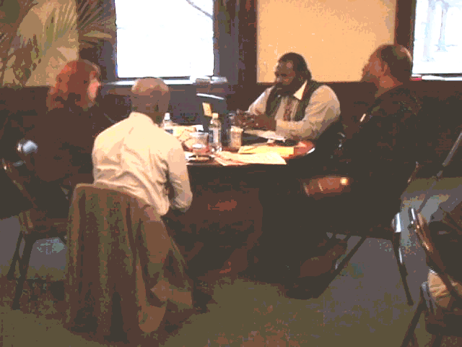

Collaborative Planning is a strategy for working together to solve problems. It helps you become the planner of your own life, with the help of a supporter who brings out your best thinking.

Working together as Planners and Supporters

The best partner is the one who brings out the best in you. As you work through this Journey Book – sharing stories, working out problems, writing a profile, and making plans – your Collaborative Planning Partner’s job is not to tell you what to do, but to help YOU explore, develop and explain your best ideas. And when you switch roles and support someone else, your job is to do the same for them.

The Role of a

I am following you. . . tell me more.

Help me understand: What is your key point?

What is your purpose in saying that?

But what if someone else listening to you would say. . .?

Planner—offers ideas about the questions at hand.

Supporter—helps the Planner develop those ideas by asking the following kinds of questions:

As a Supporter, one of these
What do you mean?
How so? (How would you do that?)
Such as? (Give me an example.)
How do you know? (Evidence?)
Why?
But what if?
Why not?
So what? (what’s the point?) Have you considered (someone else’s) point of view?

questions might help your
partner to e x p a n d
his or her ideas:

STORY BEHIND THE STORY

A Strategy for Getting at the Whole Truth
.

The story that no one hears

You’ve seen the media images of urban teenagers or new employees—they show people with an attitude, no work ethic, or low skills. But where are the positive stories of young people or employees and their communities? Where is the story about trying to find child care and transportation on a limited budget or about the stresses of low-income jobs? These are the stories- behind-the-story that no one hears—stories that people in urban communities could tell But if no one hears the whole truth, then how will the problems be solved?

Getting the story behind the story is a strategy for going beyond merely telling WHAT happened, to telling WHY and HOW. It lets people see how young people or employees read that situation, what was going on in their mind, and what it meant to them. . This strategy helps people tell the story behind the story so that others will understand

Telling more

Here are some techniques and questions that you can ask yourself or someone else to get at (and tell) the story-behind-the-story.

- How does your experiences compare to the popular images, ideas, and opinions about people in your community? Is what the media thinks about you the same thing that you know about yourself and your neighborhood?

- Tell revealing, specific details that tell how the situation looked or felt from your perspective.

- Go into the minds of different people in as you tell your story and, as they are talking, show what they are thinking to themselves as well.

- Show the evidence or experience that supports your ideas. Imagine you are cooking a special recipe: what are the ingredients that make up your opinions, ideas, and knowledge?

How do you begin a Story-Behind-the-Story dialogue?
What the Story Teller Does | What the Planning Partners Do
Start the Story  You are the story teller, so tell us about the problem you faced. Make your story lead up to the point at which you had to make a difficult decision.  But as soon as you describe that moment—before you tell us what you did or why—STOP! | Listen with imagination
Ask for Predictions  Now ask us to predict what we think you did. See how many rival hypotheses you can get us to imagine.  As the story teller, you get to ask us 3 hard questions:  What decision do you think I made? And why?  What do you think the problem is here?  Whose problem is it? | Predict Rival Possibilities  See how many different rival hypotheses you can imagine :  What did the story teller decide ?  What is the real problem here ?  Whose problem is it?

Reveal the Story  Tell us about your decision.  What did you do?  Why?  What is the problem here?  If it was a bad decision, how did you recover?  Tip: Jot down good rivals and your own answers . Include these when you write your Portrait for Chapter One | Get the Story-Behind-the-Story  Here is where you—the planning partner—can help the story teller dig deeper. Your job is to ask:  Why? What is the real problem here?  How did you feel about yourself? Were you proud of something? Did other people see it the same way?  Did you learn something from this experience about yourself or others?


RIVALING

A Strategy for Bringing More Voices
to the Table and Into Your Plan

• How do you find support in your community?
• Do certain things keep urban teens from succeeding in the new world of work?
• How can you best plan to meet your life goals?

Open questions call for rival hypotheses

Important questions like the three above don’t have single “right” answers. That is why they are called open questions. When you are dealing with hard-to-answer questions, it helps to see the problem from different points of view. A traditional hypothesis is an educated guess, a prediction, or a theory about something. A rival hypothesis gives you another way of looking at the situation.

It is not easy to answer a question such as, “Do certain things keep urban teens from succeeding in the new world of work?" To answer such a question, one needs first to recognize that there are a number of good rival hypotheses. Secondly, one needs to try to include these good points in the answer to this question.

Coming up with good rivals

The goal of rivaling is not to beat a rival or win an argument against an opponent. Instead, you are looking for good rival ideas so you can figure out “the whole truth.” So how do you come up with good rivals?

One way to gain rivals is to invite different people—such as adults and teenagers—to the discussion table. Ask them to talk about the problem from their special perspectives.
Who would you invite to the table to give rivals about the question: “Do certain things keep urban teens from succeeding in the new world of work?”

An employer with good or bad experiences
An employee with good or bad experiences
A conservative or liberal politician
A job trainer
A teenager
A single mother
A minister
Who else?

A second way is to come up with rivals in your own head. Use your own experience, or try to imagine what different people would say if you asked them about your problem. Try to think about alternative ways you could read a situation, different ways someone could define the problem, or alternative solutions someone might propose. You might try to start a conversation in your own mind and imagine what different people would say.

Remember, you will know that you have become an ace rivaler when you can finally rival your own ideas.

Review Your Stories: Do they show the signs of STRONG DECISION MAKING ?

Look at your stories and give each one a √ if it has the following features
√ √
Specifics: It is detailed and elaborated with specifics

Steps: It spells out specific actions or steps I took

Personal fit: It is personal and clearly refers to my situation (beyond what anyone might say about this general problem)

Reasons: It goes further to explain my idea by giving reasons with words like “since” or “because” or “so.”

Rivals It raises rivals and talks about alternatives to my own ideas

So how strong is the decision making in your stories?
Scores:
10-8 This is a STRONG decision chapter that shows lots of reflection.
7-5 Very Good. This has lots of good thinking.
4- 3 Trying Hard? A good start. Where could you make your story more reflective?
2-0 Needs Some Work!

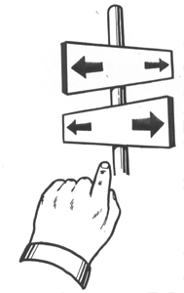
Options and Outcomes

A Strategy for Making Strong Decisions

What are my Options?

Every time you make a decision to DO something, you are making a decision NOT to do some alternative thing.

My kid was sick last week again, and I knew that she shouldn't be going to school. I could have asked my mother to watch her, but I just couldn't face taking the bus to her house and then taking two more to work. So instead, I called out from work again, even though I was told I didn't have any sick days left ---Mychelle

Every step Mychelle took was a decision that was surrounded by other steps -- other options she could have taken that would have led her in a different direction.

Sometimes, when lots of other people are stepping in the same direction, we don’t even notice all the options we have. Options and Outcomes is a strategy for making better decisions by:

How do I make a good decision?

- It’s not easy. Sometimes the easy option, the popular decision, or the one your peers expect you to take is not the best.

- Values. A good decision is one that helps you reach your personal goals and reflects your values.

- Actions. It lets you say by your actions: “This is what I want to achieve and what I believe in.”

- Likely. Choose among options by asking: “What is the chance that this option will let me reach my goals or reflect my values?” Is it just a long shot? Are you doing wishful thinking instead of making a smart decision?

- Thinking of as many options as you can, and
- Imagining the possible outcomes – where each option might take you.

What is the Outcome of that Option?

How do you decide which option to take?

Why do I call out sick from work? Because I'm just overwhelmed by all of the responsibilities I have at home, and work seems the easiest thing to let go. And I haven't been fired . . . yet. ---Mychelle

How do you decide which option to take? First, try to imagine the outcome or what will happen. Mychelle considered the immediate or short-term outcome of her decision to call off from work – “I probably won't be fired . . . yet.” But what if she imagined the possible long-term outcomes further down the road?

Here are examples of teens brainstorming about their options and possible outcomes of their decisions:

The Problem

A student says: “I have a 4-page report due tomorrow and I didn’t start typing it yet.

OPTIONS | OUTCOMES
Don’t go to school | But I don’t like missing days
Don’t do it | But then I won’t get credit
Stay up and finish it | Be even more tired than I am but done
Ask for help (friend) | But then it won’t be done right
Do half of the report and chill out | But then I only get half credit
I might not write about the right thing | Then I would have to hear the teacher’s mouth
Should have started earlier | But I didn’t, and that’s why I’m suffering at the last minute.

Deciding
What does this decision maker value? Is this a personal (not just a popular or easy) choice? Could the student actually act on those values? And is it likely (or not) that that choice would reach the student’s goals.

The Plan
But the option that I am going to pick is that I am going to do my project and do it right so that I can get full credit for it and don’t have to hear the teacher’s mouth. Even though I am tired and don’t feel like it, I’m going to do it.”

Evaluating Past Decisions

I tried out for the basketball team. But I thought I wasn’t any good, so I stopped going to tryouts. I gave up. At that time I thought that was the best for me.
But after a while I kind of thought about other options and how that would turn out. So I got another shot at trying out, I took it, and I made the team. This was the best option for me, and I’m glad I chose this one even though I gave up at first.
Test Your Action Plan: Are You Doing STRONG DECISION MAKING ?

Want to test your strength? Strong or reflective decision makers have a special advantage because they know how to reflect or look back at their own decisions. They are able to imagine realistic, specific actions and situations, to come up with good rivals, and to test and question their own ideas. Use this checklist to see how many of the features of a strong decision maker you can find in Chapter 2.
Look at your plan of action and give it a √ if it has the following.
Give it a second  if it has this feature in more than one place.
√ √
Specifics: It is detailed and elaborated with specifics
Steps: It spells out specific actions I could take—it lays out steps for what to do
Personal fit: It is personal and clearly refers to my situation (beyond what anyone might say about this general problem)
Reasons: It goes further to explain my idea by giving reasons with words like “since” or “because” or “so.”
Rivals It raises rivals and talks about alternatives to my own ideas
Roadblocks: Conditions: It describe the special conditions under which an option might work—or not work—with words such as “if” or “when.”
Roadblocks: Consequences: It considers possible problem outcomes with words such as “but,” or “since,” or “however.”
Reflection: It looks back at my own choices to see patterns, possible problems, or what I learned.
Add up your score. How many √s did you get?

So how strong is the first draft of your action plan?
Scores:
16-13 This is a STRONG decision that shows lots of reflection
12-9 Very Good This has lots of good thinking
8- 5 Trying Hard? A good start. Where could you make the biggest change?
4-0 Needs Some Work!

What could you do to turn your action plan into a STRONGER DECiSION ?
REVISE YOUR DRAFT and do a new REVIEW
Place all your work in Chapter Two of your Journey Book

